

January 05, 2017

Dear **Sir/Maam**:

Vibal responds to the Philippine K to 12 Curriculum mandate of meeting the needs of 21st-century learners. In line with the Department of Education's vision of producing holistic scholars, we want to help educators and students achieve a learn-work-play balance with our exciting suite of educational technology solutions.

From basic education levels to senior high school, student-centered and curriculum-aligned resources are matched with innovative approaches such as gamified learning and the use of mobile devices and technology tools. All these lead towards a happy life where learners explore avenues for knowledge, consider career paths, and enhance their work/life skills, while maintaining time for leisure and recreational pursuits.

In line with this, we would like to invite your school to send 4 coordinators for Filipino, Math, Science, Senior High for the Coordinators’ Summit and Teacher per subject area for Macro-Seminar with the theme **“Learn, Work, Play”** on **January 13-14, 2017,** at **Eight (8) o’clock in the morning until Four (4) o’clock in the afternoon.** Please refer to the schedule below:

|  |  |  |
| --- | --- | --- |
| ***Event*** | ***Date*** | ***Venue*** |
| **Coordinators Summit** | **January 13, 2017** | **Almont Inland Hotel**  *Butuan City* |
|  |  |  |
| **Macro-Seminar for Teachers** | **January 14, 2017** | **Almont Inland Hotel**  *Butuan City* |

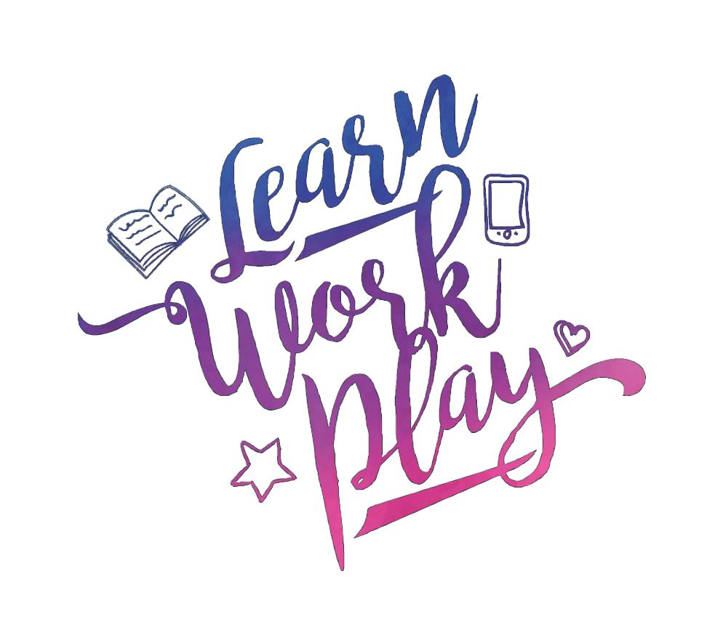Kindly confirm your attendance through e-mail at [cminoza@vibalgroup.com](mailto:cminoza@vibalgroup.com) or you may contact our Account Executive at 0932-2168-153**,** so we can send you right away the details of the program. This seminar is **FREE** of charge.

We look forward to your participation in this momentous event. Thank you.

Sincerely,

**Mark Ellorimo**

*Area Manager for Mindanao*

*Vibal Group*